**Project Deliverable - 4**

**Q&A website**

**Version 1.0**

**Approved**

**Prepared by:**

DEEPTHI POTHINENI

BINDU JAMMULA

KEERTHI CHINTA

SAISREE GUMMADI

VISHWANATH REDDY RAMAYYAGARI

SURVI VIDIT DATTA

CHANIKYA DEVARAPALLI

SHIRIDI CHAITANYA SANDHYALA

Date Created: 10-29-2021

**Table of Contents**

1. Requirements........................................................................................................................................................................................... 2

1.1 Development Phase 1…………………………………………………………………………………………………………………………………… 2

1.2 Development Phase 2…………………………………………………………………………………………………………………………………… 2

1.3 Development Phase 3…………………………………………………………………………………………………………………………………… 3

2. UML Diagrams........................................................................................................................................................................................... 4

2.1 Class Diagram................................................................................................................................................................................……... 4

2.2 Sequence Diagram.....................................................................................................................................................................…….... 5

2.3 Use Case Diagram................................................................................................................................................................................. 6

2.3.1 Use Case Success Diagram……………………………………………………………………………………………………………………….... 7

2.3.2 Use Case Error Diagram………………………………………………………………………………………………………………………………. 7

2.3.3. Final Use Case Diagram…………………………………………………………………………………………………………………………........8

3. Test Cases (Unit Tests) ........................................................................................................................................................................... 9

4. User Manual…………………………………………………………………………………………………………………………………....................... 13

5. Web Application Usage Instructions…………………………………………………………………………………………………………...... 21

6. Feedback from Code Inspection Session………………………………………………………………………………………………………. 22

7. Accomplishments and Improvisions……………………………………………………………………………………………………………… 22

7. Member Contribution Table ………………………….…………………………………………………………………………….………………. 23

**1. Requirements:**

**1.1 Development Phase 1**: We are with the initial plan for the phase 1 development. Therefore, giving a brief description of the phase 1 requirements and functionalities from deliverable-2.

|  |
| --- |
| **UI - HOME PAGE**- The home page contains everything the user is looking for in a quick glimpse. It has transitions which will walk the user through our hotel experience. When we scroll down in a home page, we see the types of rooms we offer including the elaboration of the kind of services out hotel provides. When we go the very bottom of the home page, we see the user reviews which are posted to our website and a book now option which navigates us to the booking page.  **UI – REGISTRATION**- In the registration page we have to fill up the basic user contact details like the username email address phone number and address and click sign up where the user will be able to use his id from the next time while booking. In the registration page few fields have conditions for example when we consider password must have at least one upper case letter, one lower case, one number and it should be 8 characters in minimum. The first name and last name should not contain numbers and the email should be valid. |
| **DATABASE USER DATA LINKING** – We use MYSQL in the back end to store the user data in the tables. This data is linked through php and once we click the sign up or submit button in the registration page the data is stored in the respective tables in the back end. When the user logins from the login page the data is fetched from the backend and verified if the user data is correct or not and then proceeds to login.  **1.2 Development Phase 2:**  **UI HOME PAGE-** This page contains Creation of headers, body and footer pages. Also, Addition of the text box and imageposting features. |
| **DATABASE UPDATION (ORDER CREATION)-** When a user finish adding or Commenting on the post data flow is checked whether it is updating in the database or not. User ID is linked to his specific order table.  **DATABASE EXTRACTION-** Based on the posts, Extraction of the data can be done from the database using php and Mysql functions.  **DATA ALIGNMENT-** Once the User posts the content on the UI, Alignment of data will be done to the Center based on the format.  **LOGOUT-** Once the user is willing to come out after his update, Logout option can be used to help the user take away from home page to login page.  **1.3 Development Phase 3:**  **CREATION PAGES -** At the final stage of the development, we have created the new web pages for the required website.  New web pages   * **Edit Profile Page:**  In this page, the personal information of the user will be displayed and they have an option to edit their personal information. After editing the personal information, they can save it and the same will be persisted in the database. * **Members Page:** This page displays all the members list who are present to all the users. They can also easily find the single person using their name as the keyword. Every user can access this page without any restrictions. * **My Post Page:** End user can post any questions or queries in their own profile, that can displayed to all the users or related users. Every user can comment on that post. * **Results Page:** This page helps user to search about the user or topic and then, the related results will be displayed on the screen to the user. * **Info Page:** This page contains the information about website, the tools, functionalities, that are used for the development for this website.   **TESTING -** We chose manual testing for the test cases. To ensure fulfillment of testing, the analyzer regularly follows a composed test plan that drives them through a bunch of significant experiments. Testing is done to each page and each page functionalities.  **BUG FIXING –** While uploading the photos in the post, we faced some technical issues. Later, we found errors while updating the post and adding comments to that post. Then to solve these hurdles, we have done the bug fixing.  **RE-EVALUATION –** After the bug fixing, again we run all the code to check whether there are any issues or errors. |
|  |
|  |

**2. UML Diagrams:**

**2.1** **Class diagram**

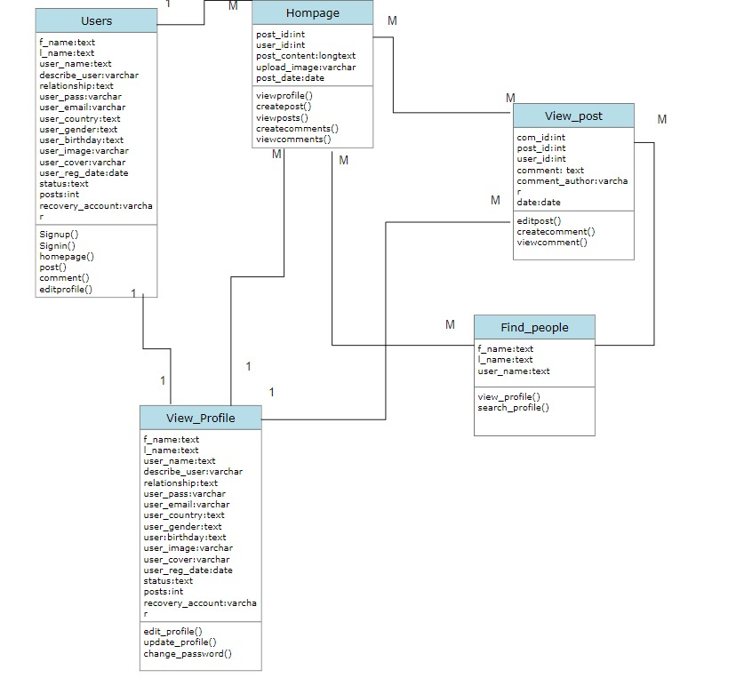

**2.2 Sequence diagram**

**2.3 Use case diagram**

**2.3.1 Use Case Success Diagram**

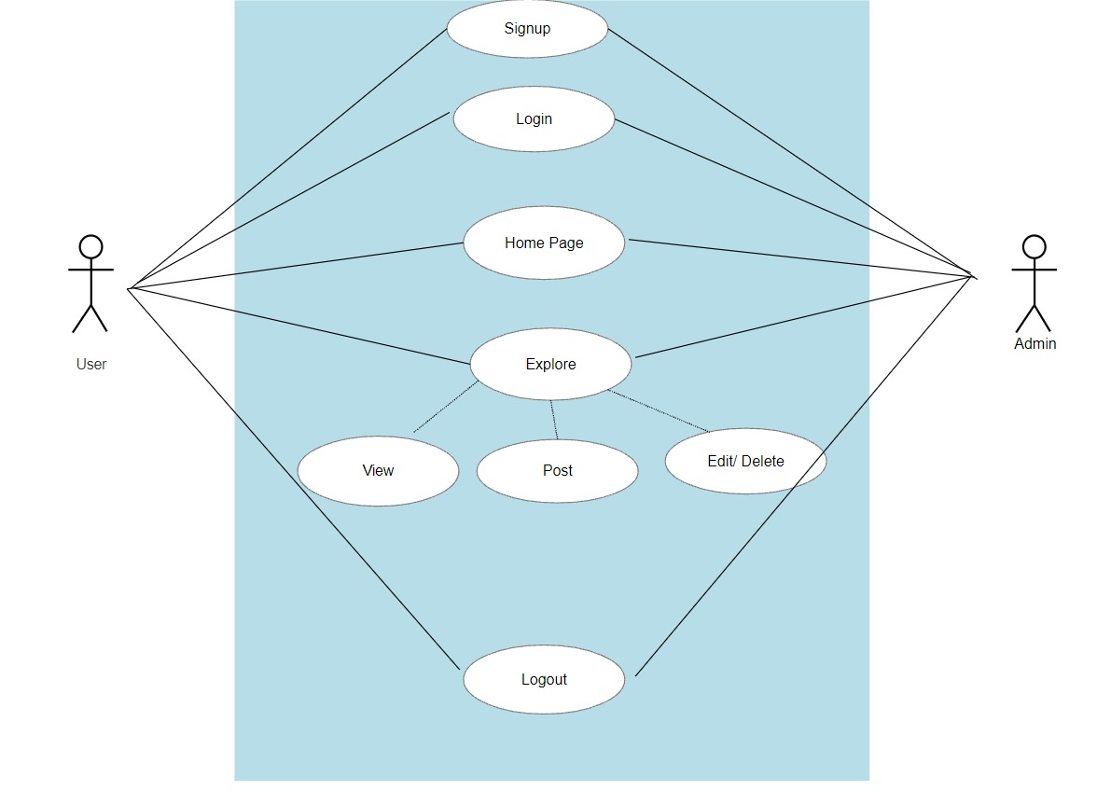

**2.3.2 Use Case Error Diagram**

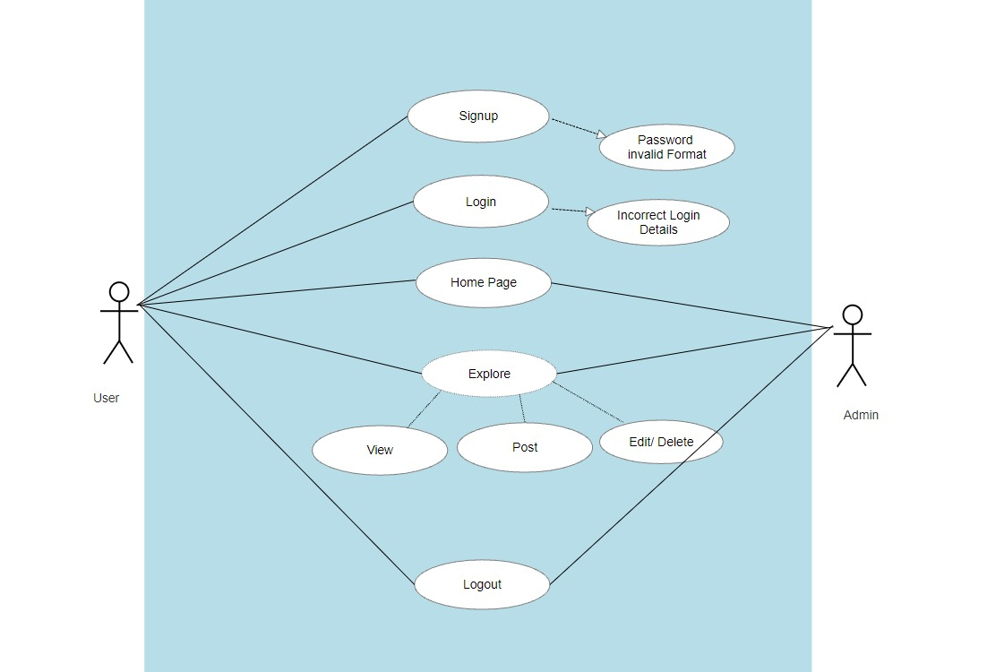

**2.3.3 Final Use Case Diagram**

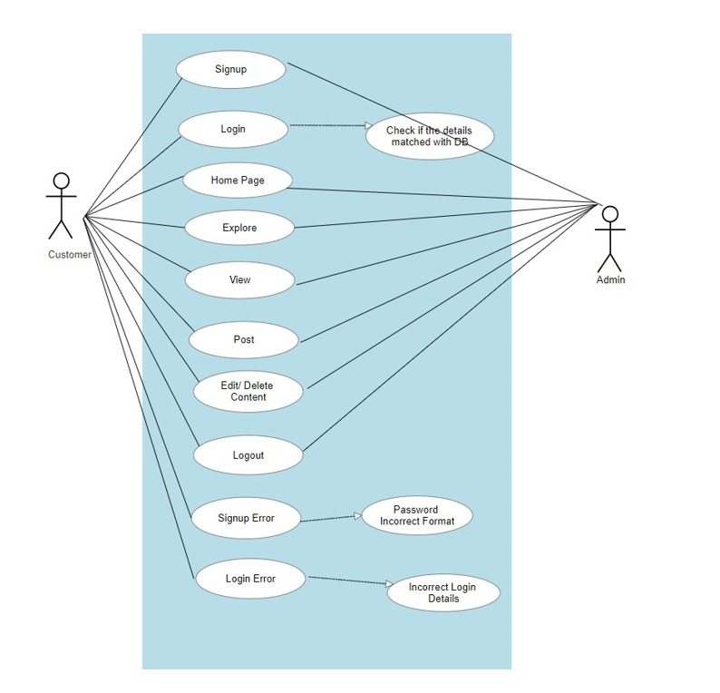

**3. Test Cases:**

List a set of test cases used for testing the working program including descriptions of tests (e.g., what functionality they test, and inputs/outputs for them)

|  |  |  |  |  |
| --- | --- | --- | --- | --- |
| Test Case Number | Functionality | Expected result | Actual result | Success/Failure |
| 1. | Registration:  Enter all the required fields. First Name, Last Name, Password (Less than 8 Characters), Email, Country, Gender and Date of Birth. | Incorrect data | Incorrect data | Fail |
| 2. | Registration:  Enter all the required fields. First Name, Last Name, Password (equal or greater 8 characters), Email, Country, Gender and Date of Birth. | Match the right format | Match the right format | Success |
| 3. | Registration:  Enter all the required fields. First Name, Last Name, Password, Email (already existing email), Country, Gender and Date of Birth. | Incorrect data | Incorrect data | Fail |
| 4. | Registration:  1.Enter all the required fields. First Name, Last Name, Password, Email, Country, Gender and Date of Birth.  2.Click on signup | Enters the home page | Enters the home page | Success |
| 5. | Login:  1.Enter all requires fields. Username (invalid username) and password (invalid password)  2.Click Login | Incorrect data | Incorrect data | Fail |
| 6. | Login:  1.Enter the username and password  2.Click Login | Enters the home page | Enters the home page | Success |
| 7. | Onclick of Post your Question Block | Allows the user to write the queries | Allowing the user to write the queries | Success |
| 8. | Onclick of Select Image Button | Should allow the user to select the image from his local memory | Allowing the user to select the image from his local memory | Success |
| 9. | Onclick of Search Block | Should allow the user to lookup anything in the community including users | Allowing the user to lookup anything in the community including users | Success |
| 10. | Onclick of My Profile | Should allow the user to upload display and cover photo, look at personal information and can edit. | Allowing the user to upload display and cover photo, look at personal information and can edit. | Success |
| 11. | Onclick of Logout | Should allow the user to take the user away from home page to login page. | Allowing the user to take the user away from home page to login page. | Success |
| 12. | Enter Question/text and click on post | Post should be created and shown on home screen. | Post is created successful message is displayed. | Success |
| 13. | Click on view post | Entire post should be displayed along with comments | Post is displayed and comments are displayed | Success |
| 14. | Enter comment and click on submit | Comment should be posted successfully, and message should be displayed | Comment posted along with a successful message | Success |
| 15. | Click on view profile | Profile page should be displayed | Profile page is displayed | Success |
| 16. | Click on Edit profile | Edit Profile page should be displayed | Edit Profile page is displayed | Success |
| 17. | Edit profile and click on submit | Changes should be updated with successful message | Profile is edited and appropriate message is displayed | Success |
| 18. | Edit post from profile page | It should navigate to Edit post page | Edit post page is displayed | success |
| 19. | Edit post and click on submit | Post should be edited, and successful message should be displayed. | Post is edited and message is displayed accordingly. | Success |
| 20. | Add image and click on submit | Image should be added, and success message is displayed. | Successful message is displayed along with added image. | Success |
| 21. | Add comment and click on submit | Comment should be added with an appropriate message | Comment is added and successful message is displayed | Success |
| 22. | Delete post and click on submit. | Post should be deleted along with comments to it and message should be displayed. | Post and comments are deleted, and message is displayed. | Success |
| 23. | Click on comments on home screen. | It should be navigated to posts page and comments should be displayed. | Post page is displayed, and comments are shown as well | Success |
| 24. | Click on my posts. | My posts page should be displayed along with all the posts posted by that user. | All the user posts are displayed along with comments added to it. | Success |
| 25. | Delete posts with images. | Images should be deleted along with posts and comments. | Posts along with posted comments and images are deleted. | Success |
| 26. | Update profile photo with existing one. | Profile photo should be updated with existing one. | Profile photo is updated with existing one. | Success. |
| 27. | Search for non-existing users in find people page. | No users should be displayed | No users are displayed with search username input field. | Success. |
| 28. | Search for post that is not existed. | No results should be displayed. | No results are displayed with input post input field is displayed. | Success. |
| 29. | Click on questionnaire logo. | It should re-direct to home page. | Home page is displayed along with existing posts. | Success. |
| 30. | Search post with multiple results displayed. | Based on entered key word if multiple posts exist all of them should be displayed along with comments. | Based on entered key word if multiple posts exist all of them are displayed along with comments. | Success. |

**4**. **User Manual**

A user manual that tells us how to install/use your program. This is meant for the end-user of the software. You may include screen shots, where appropriate.

**Login page:**

* Any registered user with a valid Email ID and password can login to their account from this page.
* After entering the required details, a click on the Login button will navigate the user to homepage.
* If an invalid email address or password is provided by the user, then it displays an popup saying “Incorrect details, Try Again”.
* For the new users who want to register can click on “Don’t have an account” which takes the user to registration . Graphical user interface

  Description automatically generated with medium confidence

**Registration Page:**

* Any user can register himself/herself by filling out the following details, First Name, Lastname, Password, Email, Gender, Country, and Date of Birth.
* All the details marked with red asterisk are mandatory to register and a warning “Please fill out this field” error is generated.
* On clicking the Sign-up button, the system validates all the information provided and creates an account in the database if it is valid.
* User is once again navigated to login page where his credentials are validated and then will be taken to homepage.

**Homepage:**

* After successful authentication user will be able to see home page, User can write his queries in Post your question block and click on ‘Post’ to post in the community. The user can even select image from his local memory by clicking on ‘select image’.

* The search can be used to look up anything in the community including users

* Clicking on ‘Find people’, One can be used to search for existing users
* Graphical user interface, website

  Description automatically generatedOn clicking ‘More’ user can look at his post history, can edit his profile, look at the terms and his privacy settings.

* Clicking on edit profile will enable user to edit his details when required and clicking on my posts user could look at his post history.

* Clicking on the users name will open up his profile page where he can upload his display and cover photo and can look at his personal information (gender, country,…)and can edit when required

The ‘Logout’ option will take the user away from home page back to login page.

**Constraints while Registration:**

* If an existing (already registered) user tries to register, it displays an error message pop up saying, “Email already exist, please try another”.
* A user must enter the password that contains at least a one uppercase letter, one lowercase letter, and must be of length of 8 or more characters.
* If required conditions are not met, then an error stating “Must contain at least one number and one uppercase and lowercase letter and at least 8 or more characters”
* Only letters are allowed while filling out first name and last name. Few special characters and numbers are restricted.

**5**. **Web Application Usage Instructions**

1. Download and install XAMPP in your system.
2. XAMPP for windows 7.1.32 64-bit version
3. Once XAMPP is installed, start Apache and MySQL.
4. A screenshot of a computer

   Description automatically generated

5.Change the port number on clicking the config button if there is any conflict while starting with Apache and MySQL

6. Place the executable folder i.e.

7. Open localhost/Techno8/Sign in in the browser which will open the homepage of the website

8. Click on the php files to run the php file.

9. As soon as website opens, we see the login page and user can access website.

**6.** **Feedback from code inspection session**

In the last feedback session, we are used to work on the following changes

* We are asked to add more detailed comments for better and easier understanding of code. We will get this done by next deliverable.
* We are told that the UI design could be more colorful and user friendly. we have already acted on the feedback and made required changes.

**7. Accomplishments and Improvisions:**

We have successfully developed a website with homepage login page, profile page and registration page. Although we didn’t change the UI design as per peer review, we made few cosmetic changes and code enhancements (Added comments, made more compact) as discussed in peer review. We are satisfied with what we have accomplished and few limitations we observed are no privacy settings and notifications.

We were short on time and planning to implement these capabilities in near future –

* We were working on adding encryption (SHA) for passwords to offer better security
* We are also intending on adding Forgot Password features which sends a link for creating new password to the registered email
* Make it mobile compatible.

**8. Member Contribution Table**

|  |  |  |  |
| --- | --- | --- | --- |
| Member name | Contribution description | Overall Contribution (%) | Note  (if applicable) |
| DEEPTHI POTHINENI | Backend Developer, Documentation | 12.5% | Worked on Edit Profile Page, presentation, and Deliverable Document. |
| BINDU JAMMULA | Requirement Gathering, Testing | 12.5% | Worked on Documentation and test cases. |
| KEERTHI CHINTA | UI Developer, Presentation | 12.5% | Worked on UML diagrams and Info page |
| SAISREE GUMMADI | UI Developer, Presentation | 12.5% | Worked on Results page and Documentation. |
| VISHWANATH REDDY RAMAYYAGARI | Database, Documentation | 12.5% | Worked on My Post Page and Testing. |
| SURVI VIDIT DATTA | Backend Developer, Presentation | 12.5% | Worked on test cases and Documentation. |
| CHANIKYA DEVARAPALLI | Backend Developer, Testing | 12.5% | Worked on the test cases, Source Code Inspection, and testing. |
| SHIRIDI CHAITANYA SANDHYALA | Database, UI Developer | 12.5% | Worked on data modelling, Members Pages and Presentation. |